CST8118 Computer Essentials Lab Assignment 1
This lab assignment addresses Course Learning Requirements (CLRs) 1, 2 and 3.

Due Date
Worksheet submission by the end of Week 6 on Friday Oct 11 by 11:59pm.
Demonstration of this lab is required in your lab period either within week 7 of the semester (or close to week 7 your lab professor will clarify the exact day).
This assignment is designed to span multiple weeks, work on this assignment in intervals as the semester progresses. Start it early, and work on it periodically.

Marks
10 Marks

Submission Guidelines
Submit your worksheet by the due date to Brightspace. Rename the file as CST8118_Assignment01_SectionNumber_YourName.docx
Come to the lab in week 7 to demonstrate portions of your work.
Print the last page of this document and bring it with you to the lab for your demonstration.
While the demonstration carries no direct marks, missing the demonstration will result in a zero for this assignment. Additionally, if you cannot answer simple questions to demonstrate concepts in this assignment to your lab professor you will lose up to 100% of the score on this assignment. Please refer to the course outline under Department Information.

Objective
The purpose of this lab is to demonstrate the ability to:
- Connect to the printers on Campus.
- Perform basic maintenance on the Windows operating system
  - via operating system updates and via antivirus updates
  - resetting network interfaces using ipconfig (release, renew, flushdns) and restarting the printer service using net stop spooler, net start spooler
- Manage files and folders on a computer system.
- Create a windows backup and restore file(s) from it.
- List the specifications for a computer.

Tools
- Laptop running Microsoft Windows 11.x
- Algonquin College Network User Id and Password
- Network Connection to the World Wide Web.

Marking
- Demonstration sheet was printed and brought to demonstration (1 mark)
- Operating System (Windows) was updated (1 mark)
- Antivirus was updated (1 mark)
- ipconfig (release, renew, flushdns) used to reset network adapter (1 mark)
- net start spooler, net stop spooler used to stop and restart printer service (1 mark)
- Requested file system created (2 mark)
- Backup created (2 mark)
- Computer specifications researched and reported (1 mark)

Procedure
If at any time that you are unsure about what to do in this lab assignment, feel free to reach out to your lab professor for help.

Part 1 Connecting to the printers on Campus.
There are many ways to print a document at Woodroffe campus. To find out how to print from your notebook computer go to: https://www.algonquincollege.com/student-print/ and select the AC Print for Windows. There is a tutorial window and instructions and a link to download the Mobility Print Windows app.
Once you are connected to a printer, you can print the last page of this document and bring it to the lab for your assignment 1 demonstration.
Bring the printed last page from this document to your lab period, so that your lab professor can record your demonstration. This is a required part of your lab demonstration.

Part 2a Basic Operating System Maintenance, updates, antivirus.

Installing Windows updates and changing active hours
Note Due to variety of different versions of the Windows operating system, the screen captures shown in this document and instructions may be slightly different from your version of the Windows operating system.
In this assignment, you will be installing any outstanding Operating System updates. You must keep the operating system up to date at least weekly.
In Windows 11, select the Windows key + “I” to open the settings menu then select the Update & Security icon.
If any updates are found, you can review them before you apply the updates to your OS and software. Once the updates are installed, you continue to the next part of the lab.
Some Windows 11 editions will allow you to defer upgrades to your PC until it is more convenient for you to install updates. If your version of Windows 10 or Windows 11 allows you to defer upgrades, continue to the next paragraph below. If your version of Windows 10 does not allow you to defer updates, you can skip ahead to the next section of the lab entitled Anti-Virus Software. If you are not sure whether your version of Windows 10 defers updates; consult with your lab instructor.
One reason to defer updates is to prevent them from being installed and your laptop from being automatically restarted at an inconvenient time. For example, it would be very inconvenient for you if your laptop downloaded and installed updates while you are in the middle of writing an online test!

Changing Active Hours
Scroll further down the Windows Update window and you will find a link to Change active hours.
Choose the start time and end time for active hours, I suggest you set your start time to be one hour before your earliest class begins and your end time to be one hour after your latest class ends, then select Save or on some versions of Windows it may be a check mark.
.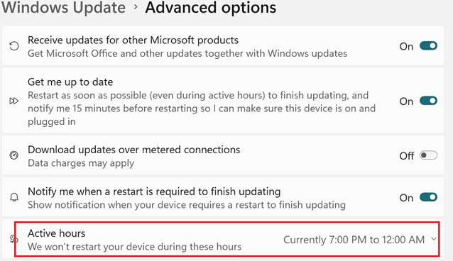
Figure 2. Windows Changing Active Hours.
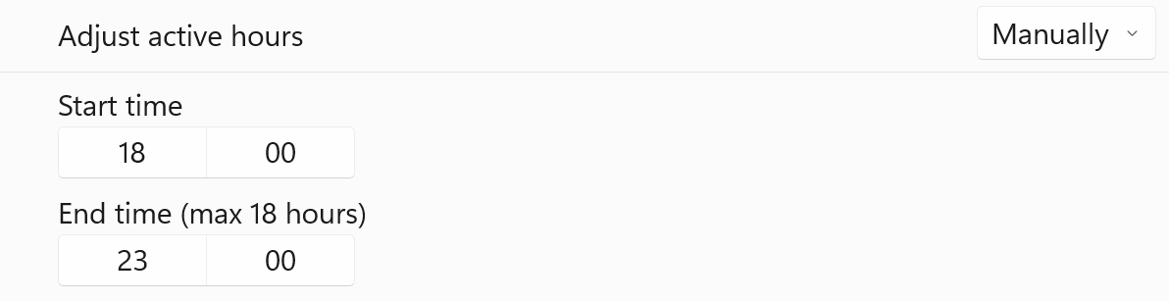
Figure 3. Setting Active Hours

Take a screen shot of the windows update screen, showing that your computer is up to date. Place this screen shot into your worksheet document.
Your lab professor may ask you to demonstrate that your operating system is up to date in lab by reviewing the windows update screen.

Anti-Virus Software
Several anti-virus products are on the market, some are better than others. Things to consider are:
- The ability to detect viruses. Some free A/V products do not update their virus definitions very often.
- The ability to scan new files on your computer. New things on your computer can come from the network, a USB key or even from PDFs or pictures on web pages. This is sometimes called “real-time” protection.
- The resources used. Some products will use a lot of memory, CPU or disk I/O, possibly interfering with normal computer use. This may encourage you to disable the product.

If you already have a non-trial version of a fully featured anti-virus product, you may use it in place of Microsoft Windows Defender. You must show the virus definitions are fully up to date.
If your system came with a trial version of anti-virus software, you should uninstall it, unless you plan to purchase it. If you need to uninstall the anti-virus program, open the “Control Panel” and choose “Uninstall a program” or “Programs and Features” depending on your Control Panel view.
If you are using another anti-virus program, ensure that its’ virus definitions are up to date.
This portion of the lab is going to assume you are using Microsoft’s Windows Defender program that came installed with Windows 11. If you are using another anti-virus product, you can skip this portion of the lab exercise and continue to the end of this section where you will take a screen shot of your antivirus program being up to date.
Start the Defender program and choose “Virus and threat protection” from the menu on the left. Verify that the Virus and threat protection updates are up to date. If they are not up to date, you will have to click on the check for updates link.
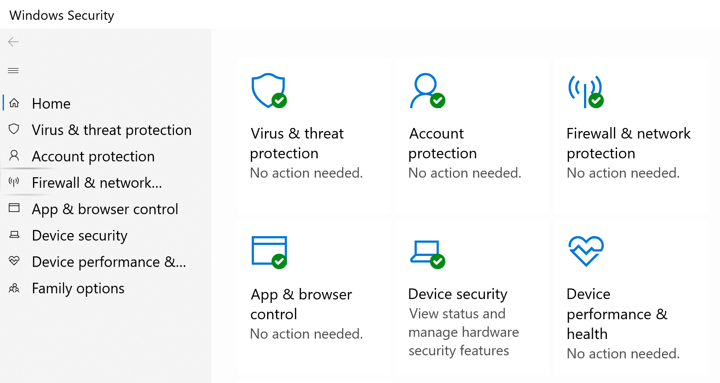
Figure 8. Windows Security

Take a screen shot of the windows security screen, showing that your computer virus and threat protection has no actions needed (i.e., is green). Alternatively, if you are using a different antivirus product take a screen shot of it instead, showing that it is up to date.
Your lab professor may ask you to demonstrate that your antivirus is up to date in lab by reviewing the windows security screen, or an alternative product if one is installed.

Part 2b Using ipconfig and net start/stop
- Using a Windows command prompt enter the following commands:
echo %date% your-name
ipconfig /release
Scroll up so that your name, and the ipconfig output are visible and take a screen shot which is to be placed into your MS Word worksheet.

- Using a Windows command prompt enter the following commands:
echo %date% your-name
ipconfig /renew
echo %date% your-name
Scroll up (or down) so that your name, and the ipconfig output, including an IPv4 address, are visible and take a screen shot which is to be placed into your MS Word worksheet.
Question: What IP Address is visible in your screen shot? (Select one IP Address which is visible in your screen shot, and type the IP address into your worksheet just below your screen shot)

- Run a Windows command prompt with administrator privileges, then enter the following commands:
echo %date% your-name
net stop spooler
Take a screenshot that has the date and your name in it, with confirmation that the service has stopped and place this into your MS Word work sheet.

- Run a Windows command prompt with administrator privileges, then enter the following commands:
echo %date% your-name
net start spooler
Take a screen shot that has the date and your name in it, with confirmation that the service(s) have started and place this into your MS Word work sheet.

Part 4 Manage files and folders on a computer system.
Create a folder structure on your hard drive that parallels the lecture course shell content area, as well as the lab course shell content area and download the lecture and lab handouts into the related folders. Minimally for the first 3 weeks of the course. Include the Course Outline, Course Information, Lecture Materials, Lab Activities, and Lab Assignment areas as well as sub-modules as folders in a similar hierarchy.
Use the tree command to document the folder structure once completed, with the file names of the downloaded files, and copy and paste the text for this into your worksheet document.
Your lab professor may ask you to demonstrate the folder structure with downloaded documents as part of your lab demonstration.

Part 5 Create a windows backup and restore file(s) from it.
Using the external USB mass storage device, create a backup of your files using either the File History utility, or the Backup and Restore (Windows 7) utility (See Control Panel, using view by Small icons).

Take a screen shot of the backup tool you used, which shows that at least one backup exists or was completed and place this into your worksheet.
Your lab professor may ask you to show your back up, as well as use the tree command, and / or request you show how to restore a file from the backup as part of your lab demonstration.

Part 7 List the specifications for a computer.
Provide a link to a laptop computer being sold from a company that sells laptops, with a price range between $1000 to $2000 Canadian dollars. This can be a laptop sold through the college bookstore, or a laptop sold by another company (examples BestBuy, Staples, Walmart, Cost Co, Canada Computers, Newegg.ca, and so on). Note: Algonquin College is not affiliated with any of the listed external companies, use their product listings for informational / educational purposes only as part of this lab).
Look for a Specifications (or Specs) section or tab and report the specifications for the following in your worksheet.
- The CPU name, number and types of cores, and cache sizes.
- The amount of RAM and the type (DDR4/DDR5)
- The secondary storage, drive(s) and types (mechanical / solid state) and storage capacities.
- The graphics processor name, model number, and amount of video memory.
- A list of the computer ports.
Your lab professor may ask you to show them the website on your laptop and explain how you were able to figure out the information you provided.

Lab Assignment 1 Demonstration Sheet

Student Name: _________________________________________
Student Number: _______________________________________
Lab Section Number: ____________________________________
Print this demonstration sheet and bring it with you to your lab period when you demonstrate the lab.
While the demonstration carries no direct marks, missing the demonstration will result in a zero for this assignment. Additionally, if you cannot answer simple questions to demonstrate concepts in this assignment to your lab professor you will lose up to 100% of the score on this assignment. Please refer to the course outline under Department Information.

CST8118 Demonstration
Required: This demonstration sheet brought to lab on paper.
Your lab professor will ask you to demonstrate two out of the following items at their choice. You are expected to be able to answer questions in all sections, but only two will be asked in lab.
Student can demonstrate:
Windows and Antivirus are up to date.
ipconfig (with release, renew, flushdns) and net start spooler, net stop spooler
The folder structure requested was created correctly, can use tree command.
A backup was created and / or can restore at least one file.
Overview of computer specifications from website.
Lab Instructor Notes:

Lab Instructor signature: ______________________________________________

